ASSIGNMENT

Q1:- What is the difference between 'Paste' and 'Paste Special' in Excel? Briefly explain with examples.

Ans:- i) Paste:-

- Definition: Simply copies the content exactly as it is from the source to the destination.
- Includes: Values, formulas, formatting, and comments.
- Example:
- Suppose cell A1 contains =B1+C1 with a blue fill color.
- If you copy A1 and paste it into D1, the formula and formatting are copied exactly.

ii) Paste Special:-

- Definition: Allows you to paste specific parts of the copied content, not everything.
- Options include:
- Values: Only the result of formulas.
- Formulas: Only the formulas without formatting.
- Formats: Only the cell formatting.
- Transpose: Switch rows to columns or vice versa.
- Multiply/Add/Subtract/Divide: Apply operations with copied numbers.

- Example:
- If A1 has =B1+C1 with a blue fill:
- Paste Special → Values into D1 → Only the result (number) is pasted; formatting and formula are ignored.
- Paste Special → Formats into D1 → Only the blue fill color is applied; the content remains unchanged.

Q2:- Describe the functions and usefulness of 'Freeze Panes' and 'Split Panes' in Excel.

Ans:- Freeze Panes vs Split Panes in Excel

1. Freeze Panes

Function: Locks specific rows or columns so they remain visible while scrolling.

Usefulness:

• Helpful for large datasets
• Keeps headers (row/column titles) visible at all times

Example:
• Freeze Top Row → Column headings stay visible while scrolling down
• Freeze First Column → Row labels stay visible while scrolling right

Use case:
If row 1 contains headings like Name, Roll No, Marks, freezing it helps read data easily while scrolling.

2. Split Panes

Function:
Divides the worksheet into multiple scrollable sections.

Usefulness:
• Allows viewing different parts of the same worksheet at once
• Each pane scrolls independently

Example:
• Split the sheet vertically to compare column A with column Z
• Split horizontally to view top and bottom data together

Use case:
Comparing data from different sections of a large worksheet simultaneously.

Q3:- Explain the difference between inserting a new row and inserting a new column in Excel. Can you insert multiple rows or columns at once?

Ans:- Difference Between Inserting a New Row and a New Column in Excel

1. Inserting a New Row
• Adds a horizontal row.
• The new row is inserted above the selected row.
• Existing rows shift downward.

Example:
If you insert a row at row 5, the new row appears at row 5, and old row 5 moves to row 6.

2. Inserting a New Column
• Adds a vertical column.
• The new column is inserted to the left of the selected column.
• Existing columns shift to the right.

Example:
If you insert a column at column C, the new column appears at column C, and old column C becomes D.

Can You Insert Multiple Rows or Columns at Once? Yes
• Select multiple rows → Right-click → Insert → same number of rows are added.
• Select multiple columns → Right-click → Insert → same number of columns are added.

Q4:-What are logical functions in Excel? Provide examples of at least two logical functions and their applications.

Ans:- Logical Functions in Excel

Logical functions in Excel are used to test conditions and return results based on whether the condition is TRUE or FALSE. They help in decision-making and data analysis.

Examples of Logical Functions

1. IF Function
• Purpose: Performs a logical test and returns one value if TRUE and another if FALSE.
Syntax: =IF(condition, value_if_true, value_if_false)

Example:
=IF(A1 >= 40, "Pass", "Fail")

Application:
Used to decide results like Pass/Fail, Eligible/Not Eligible, Bonus/No Bonus.

2. AND Function
• Purpose: Returns TRUE only if all conditions are TRUE.

Syntax: =AND(condition1, condition2, ...)

Example: =AND(A1 >= 40, B1 >= 40)

Application: Used when multiple criteria must be satisfied, such as passing all subjects.

3. OR Function
• Purpose: Returns TRUE if any one condition is TRUE.

Example: =OR(A1 < 40, B1 < 40)

Application: Used to check if any condition fails, such as detecting errors or low scores.

Q5:-Discuss the purpose of 'XLOOKUP' and how it differs from the traditional 'VLOOKUP' function.

Ans:-Purpose of XLOOKUP:-

- XLOOKUP is used to search a value in a range and return the corresponding result from another range.
- It helps in finding data accurately and easily from large datasets.
- XLOOKUP is designed to replace older functions like VLOOKUP and HLOOKUP.
- It allows flexible searching in any direction (left, right, up, or down).
- It reduces errors and makes formulas simpler and more reliable.

Difference between XLOOKUP and VLOOKUP:-

i) Search Direction

- XLOOKUP can search both left and right.
- VLOOKUP can search only from left to right.

ii) Column Index Requirement

- XLOOKUP does not require a column number.
- VLOOKUP requires a column index number.

iii) Exact Match

- XLOOKUP performs an exact match by default.
- VLOOKUP needs FALSE for an exact match.

iv) Error Handling

- XLOOKUP has built-in error handling (if not found).
- VLOOKUP needs IFERROR separately.

v) Impact of Column Insertion

- XLOOKUP does not break if columns are added or removed.
- VLOOKUP may give wrong results if columns change.

vi) Vertical and Horizontal Lookup

- XLOOKUP works for both vertical and horizontal lookups.
- VLOOKUP works only for vertical lookups.

vii) Multiple Match Handling
- XLOOKUP can return the first or last match.
- VLOOKUP returns only the first match.

Q6:-Create a worksheet titled 'Employee Data' with columns: Name, Age, Department. Add 5 rows of data. Format as follows:
● Bold and center-align the header row
● Apply a fill color
● Auto-fit column width

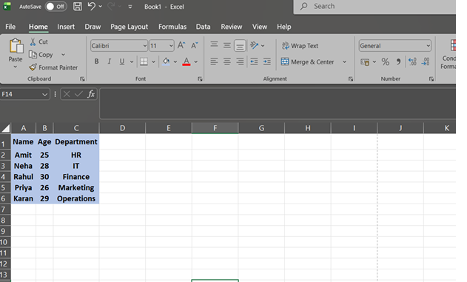

Q7:-Demonstrate how to insert and delete multiple rows and columns in Excel. (Provide screenshots before and after the changes.)

Ans:-Demonstrating How to Insert and Delete Multiple Rows and Columns in Excel

A. Insert Multiple Rows and Columns

Insert Multiple Rows

Steps:

1. Select the same number of rows you want to insert (e.g., select rows 3–5).
2. Right-click on the selected rows.
3. Click Insert.
4. Excel inserts the same number of new rows above the selection.
Insert Multiple Columns

Steps:
1. Select the same number of columns you want to insert (e.g., select columns B–D).
2. Right-click on the selected columns.
3. Click Insert.
4. Excel inserts the new columns to the left of the selection.

Before & After (Insert)

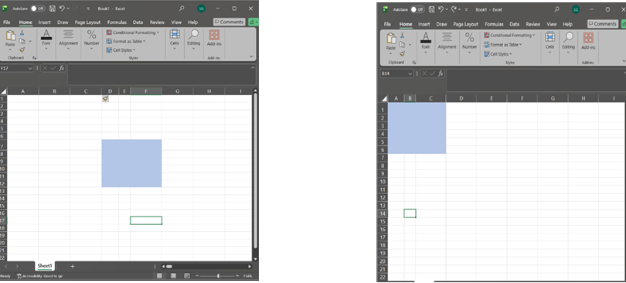

Before After

B. Delete Multiple Rows and Columns

Delete Multiple Rows

Steps:
1. Select the rows you want to delete (e.g., rows 6–8).
2. Right-click → Delete.
3. Selected rows are removed and remaining rows shift up.

Delete Multiple Columns

Steps:
1. Select the columns you want to delete (e.g., columns D–E).
2. Right-click → Delete.
3. Selected columns are removed and remaining columns shift left.

Before & After (Delete)

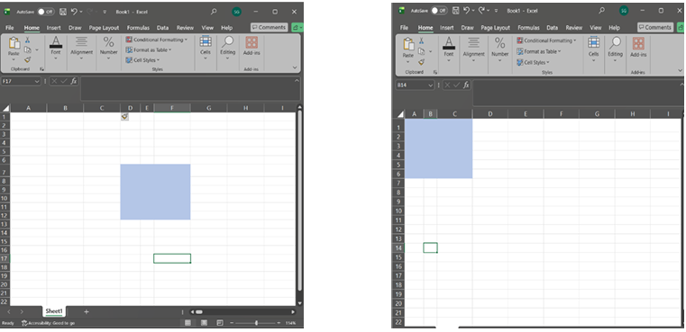

Before After

Q8:-Use Excel's 'Find and Replace' feature to update department names in a sample table. (Include a screenshot showing the replaced data.)

Ans : Using Excel’s Find and Replace to Update Department Names Screen Shot (Before Replace)
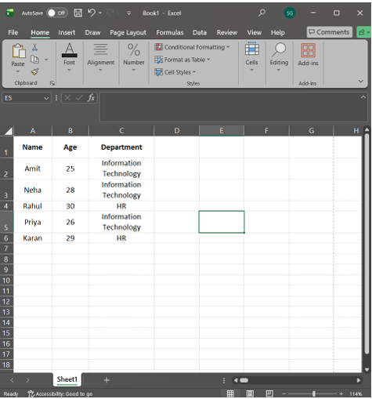

Steps to Use Find and Replace
1. Select the Department column (or the entire table).
2. Press Ctrl + H → Find and Replace dialog box opens.
3. In Find what, type: IT
4. In Replace with, type: Information Technology Click
5.Replace All.
6. Excel confirms how many replacements were made.

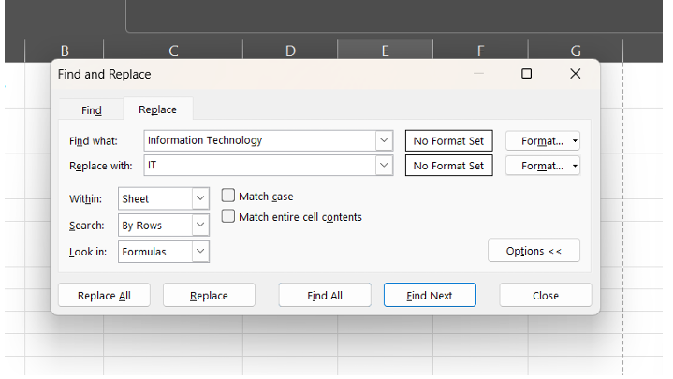

Screenshot Showing Replaced Data
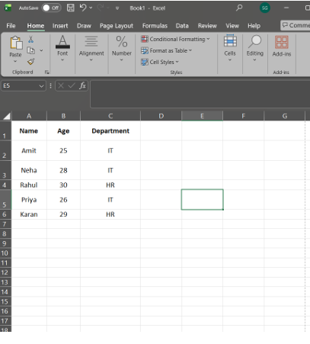

Q9:-Create a small numerical dataset and apply the following functions:
● AVERAGE
● MAX
● MIN
(Include a screenshot showing the formulas and their results.)

Ans:-

Applying AVERAGE, MAX, and MIN Functions in Excel

Step 1: Create a Small Numerical Dataset

A (Values)
10
20
30
40
50

Step 2: Apply the Functions

Function Formula Used Result

AVERAGE =AVERAGE(A1:A5) 30

MAX =MAX(A1:A5) 50

MIN =MIN(A1:A5) 10

Explanation

• AVERAGE calculates the mean of the numbers.

• MAX returns the highest value in the range.

• MIN returns the lowest value in the range.

Showing Formulas and Results

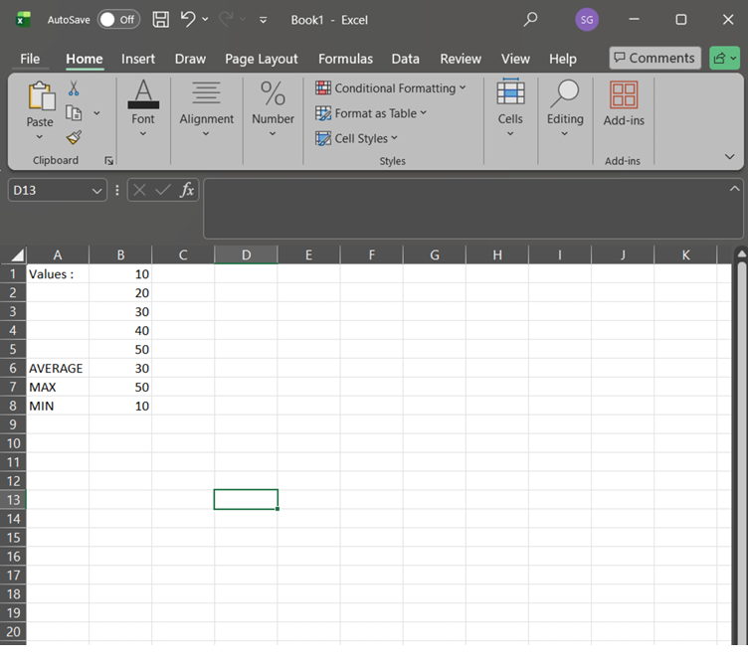

Q10:-You're working with a dataset that contains missing values. As a Data Scientist, explain how you'd detect and handle missing data using Excel. Mention tools like:
● Go To Special
● ISBLANK
● COUNTBLANK
(Include a screenshot showing how blanks are identified or processed.)

Ans:-Detecting and Handling Missing Data in Excel (as a Data Scientist)
When working with real-world datasets, missing values are common. In Excel, I would first detect missing data and then handle it appropriately using built-in tools and functions.

1. Detecting Missing Data
a) Go To Special
Purpose: Quickly identifies blank cells in a selected range.
Steps:
1. Select the dataset.
2. Press Ctrl + G → Click Special.
3. Choose Blanks → Click OK.
4. Excel highlights all blank cells.

Usefulness: Fast visual identification of missing values in large datasets.

b) ISBLANK Function

Purpose: Checks whether a specific cell is empty.

Syntax: =ISBLANK(A2)

Result:
• Returns TRUE if the cell is blank
• Returns FALSE if the cell has data

Application: Used to flag missing values or create conditional logic (e.g., marking rows with missing data).

c) COUNTBLANK Function

Purpose: Counts the total number of blank cells in a range.

Syntax: =COUNTBLANK(A2:A20)

Application: Helps quantify how much data is missing before deciding how to handle it.

2. Handling Missing Data in Excel

After detecting missing values, I may:

• Delete rows with missing data (if very few and insignificant)
• Replace blanks using:

o Mean/Median (for numerical data)
o “Not Available” or “Unknown” (for categorical data)

• Use IF + ISBLANK to fill values conditionally

Example: =IF(ISBLANK(A2), AVERAGE(A:A), A2)

Screenshot Showing Blank Identification / Processing

